# resQwest Wordpress Plugin Manual - Embedded Easy Api

Contents

resQwest Wordpress Plugin Manual - Embedded Easy Api 1

Overview 1

Installation 1

Step 1 1

Step 2 2

Step 3 2

Embedded Easy API 3

Enabling 3

Routes 3

Shortcode 3

## Overview

The resQwest Easy Api Wordpress Plugin is designed to make integrating resQwest and wordpress easy.

## Installation

### Step 1

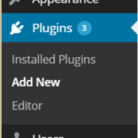Select the “Add New” menu option under Plugins in the left panel of the wordpress administration screen. On the “Install Plugins” page that appears, you will see a link titled “Upload”. Click this.

### Step 2

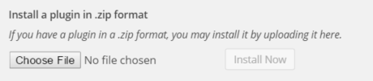

Click on the “Choose File” button and browse to where you have downloaded the “resQwest.zip” file.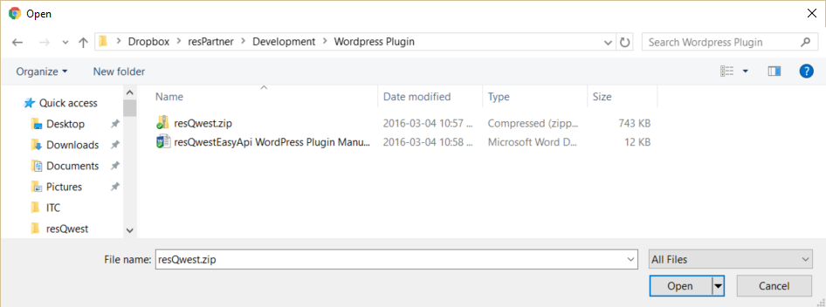

Please choose and open that file.



### Step 3

Then click the “Install Now” button to install the plugin. The plugin will install and then please click the “Activate Plugin” link.

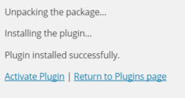

The plugin should now have successfully activated.



## Embedded Easy API

The resQwest Embedded Easy API offers the ability to embed bookability directly within a wordpress page or post.

### Enabling

When you edit a page or post you will see a resQwest configuration box near the bottom of the edit screen.

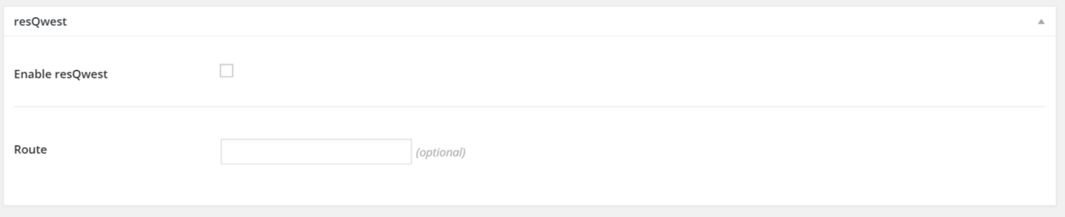

The “enable resQwest” allows you to enable the resQwest Easy Api within this page.

### Routes

The additional “Route” setting allows you to specify if a specific Category or Activity should be loaded. Leaving this blank will cause the default view for your website to be loaded, likely an all categories view.

### Shortcode

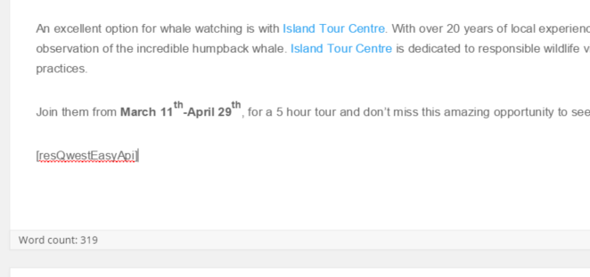

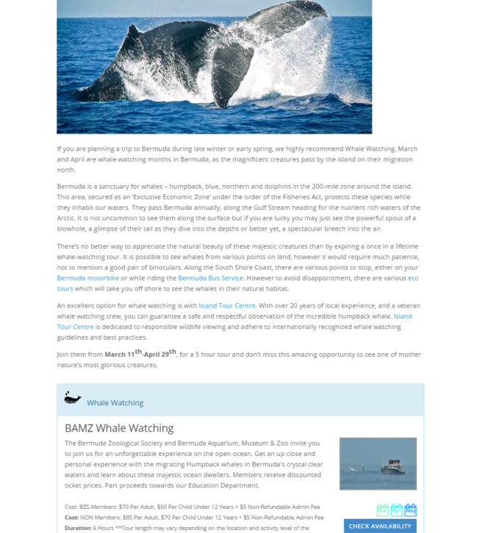If you’d like the API to appear within a specifc area of the page’s content you can add a wordpress “ShortCode” of [resQwestEasyApi] to designate where you’d like the api to be loaded.

This enables the Easy Api to be loaded within the page in the location you specify.